|  |  |  |  |
| --- | --- | --- | --- |
|  | **Name (Block letters)** | **:** | **KRISHNA KUMAR MONDAL** |
| **Date of Birth** | **:** | **15/11/1967** |
| **Nationality** |  | **INDIAN** |
| **Gender** |  | **MALE** |
| **II.** | **Department** | **:** | **MATHEMATICS** |
| **III.** | **Area of Interest** | **:** | **FUZZY TOPOLOGY** |
| **IV.** | **Address for correspondence (with pin code)** | **:** | **189, G.T. ROAD, BAIDYABATI, HOOGHLY, PIN-712222.** |
| **V.** | **Permanent Address (with pin code)** | **:** | **DO** |
| **VI.** | **Mobile no.** | **:** | **9474103701** |
| **VII.** | **E-mail :krishnakmondal@yahoo.co.in** | | |

|  |  |  |  |
| --- | --- | --- | --- |
|  | 1. **Date of Joining** | **:** | **01/03/2001 at Kurseong College, Kurseong** |
|  |  |  | **20/04/2010 at Rabindra Mahavidyalaya, Champadanga** |

1. **Academic Qualification (Graduation onwards):**

|  |  |  |
| --- | --- | --- |
| **Examination** | **Name of the University** | **Year of passing** |
| **B.A./B.Sc./B.Com.** | **VISVA-BHARATI** | **1990** |
| **M.A./M.Sc./M.Com.** | **VISVA-BHARATI** | **1992** |
| **Ph.D** | **VISVA-BHARATI** | **2011** |

1. **Scholarship/Awards:**
2. **Research/ Administrative Experience:**

1. **Teaching/ Other Experience:**
2. **RESEARCH Oriented Seminars/Workshops/Conferences Attended:**

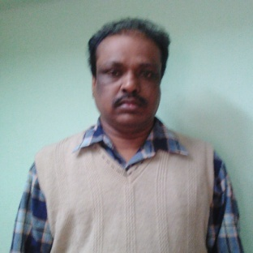

1. **List of Publications**



I declare that the particulars given above are correct to the best of my knowledge and belief.

Signature